Project Objective:

The objective of this project is to analyze organizational employee data to identify performance trends, salary and improvement opportunities, supporting better decision-making for HR management.

Problem Statement:

Many companies rely on Excel sheets to maintain employee salary records, but manual entry and lack of structured validation often led to errors such as duplicate records, incorrect salary calculations, missing payroll fields, inconsistent formatting, and difficulty in tracking department-wise salary expenses. HR and finance teams struggle to derive quick insights like salary distribution, payroll trends, compensation gaps, and overall salary statistics.

Dataset Description:

This dataset contains detailed information about employees joining an organization.
It consists of 151 records and 9 columns.

Attribute (Column/Features) Description:
Attribute Name | Data Type | Description
Employee Id | String and Numeric  (General) | Include all employee Id
Name | String (Text) | Identify Employee names
Department | String (Text) | Specify 6 department
Country | String (Text) | Specify 6 country
Salary | Numeric (Integer) | According to Department
Date of joining | Date (DD/MM/YY) | Represents the day when date of joining
Performance Rating | Numeric (Integer) | The act of doing
Gender | String (Text) | Gender intimated
Email-id | String and symbol | Our own id

Tools and Technologies:
- Excel: Data cleaning, transformation, Pivot Tables, Pivot chart, Slicer, Dashboard.
Data Pre-Processing Excel:
Task Performed:
- Data Cleaning and Transformation
- Trim and clean, remove duplicates for Employee Id
- Trim and clean, using “Isblank” condition for Name column to fill Unknown
- Use Proper case function and Find and Replace or Substitute Human ResourceHR, itIT.
- Country column using Substitute function to fill Unknown
- Salary column to fill N/A values
- Date of joining using date format
- Performance Rating empty cell using zero values
- Gender and Email id column empty cell using Unknown
- Salary column using Descriptive statistics
Visualization and Dashboard:
Pivot table:
- Department vs Max of Salaryinsert Department slicer
- Gender vs Sum of Perform Ratinginsert Gender slicer
- Name vs Average of Salaryinsert Name slicer
- Gender vs Count of Employee IDinsert Gender slice
- Gender vs Sum of salary
- Name vs Sum of Total Salary

Dashboard: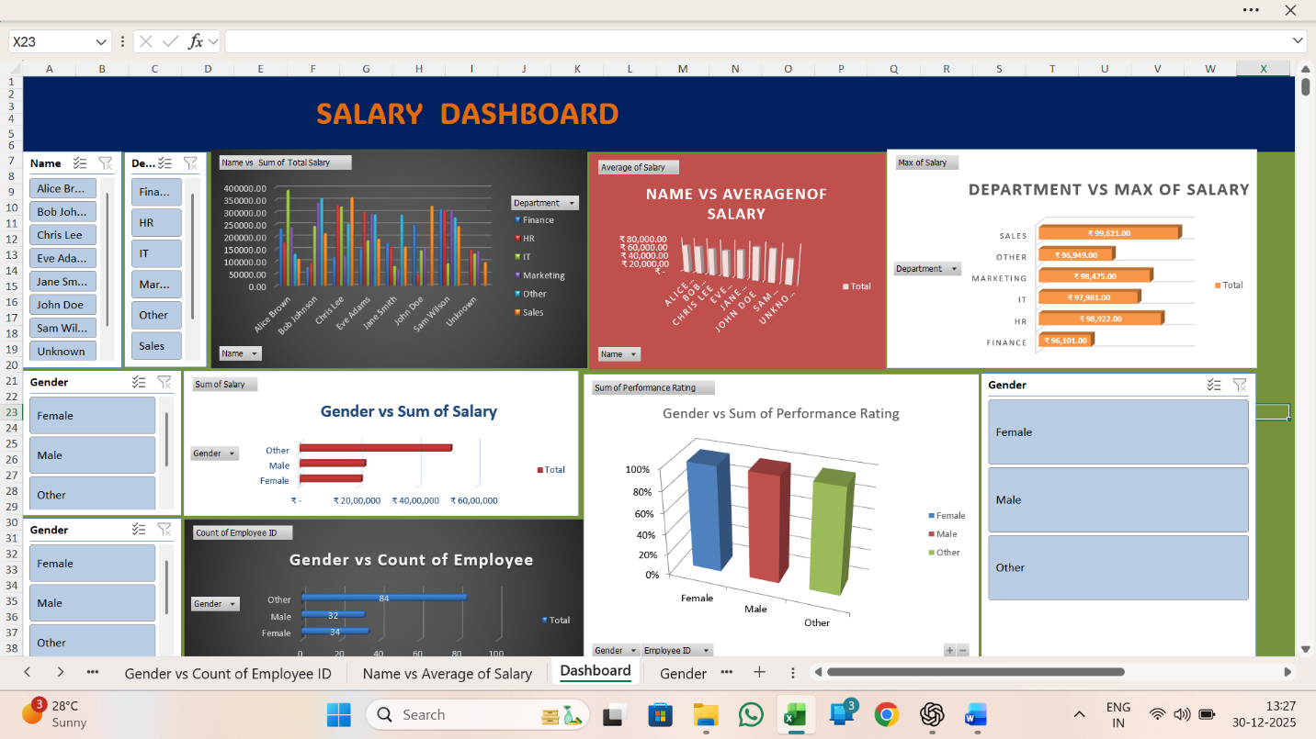
Insights and Conclusions:
Key Findings:
- The highest salary is received by senior roles such as Managers and Team Leads.
- The highest salary amounts ₹ 99,621 by Sales Department.
- The highest salary country INDIA
- Duplicate salary records were found and removed during data preprocessing, improving data accuracy.
- The IT department has the highest total payroll amounts ₹ 97,981, indicating major workforce allocation in technical roles and Performance Rating 5.
- Salary distribution analysis shows recent hiring growth after 2020, increasing payroll costs.
Conclusion:

The analysis of the employee dataset provided meaningful insights into performance rating and employee satisfaction. Through descriptive analytics, we identified patterns related to employee distribution by department and salary levels.

